AIPP LAB 15
Name: ANUMASA GAYATHRI
Hall Ticket No.: 2505B02106
Date: 25/11/2025 (Week 5)
_____________________________________________
Completed this Assignment using VS CODE Al Integration.
Task 1:
Ask Use Python (or Node.js/JavaScript) to connect to a public
API (e.g., OpenWeatherMap or JSONPlaceholder). Send a simple GET request to retrieve data. Display the response in a readable format (pretty JSON). Prompt: write a python function that display weather details of a city using weather api without error handling. Display weather details as JSON output.
CODE:
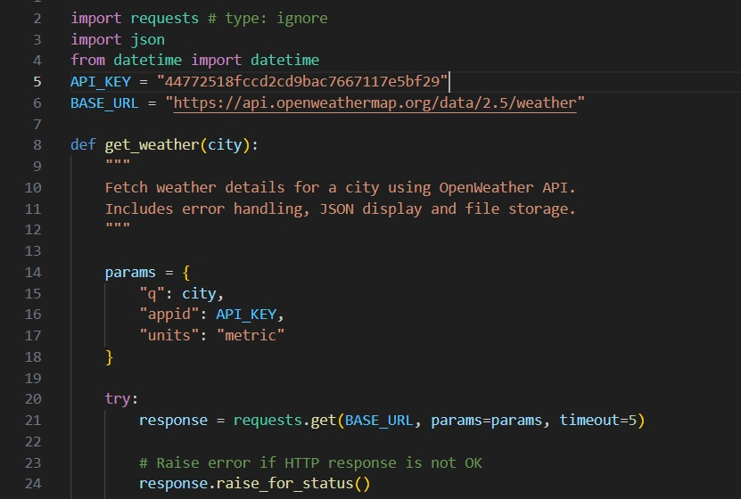
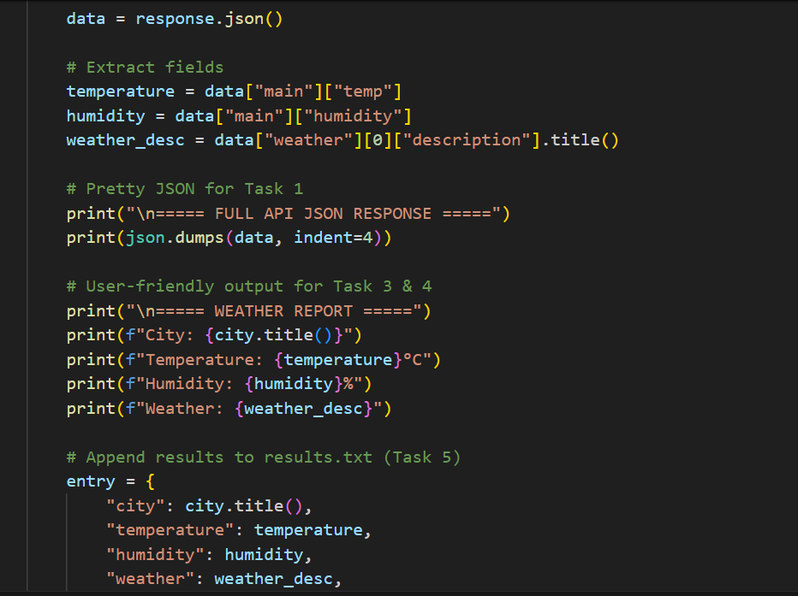
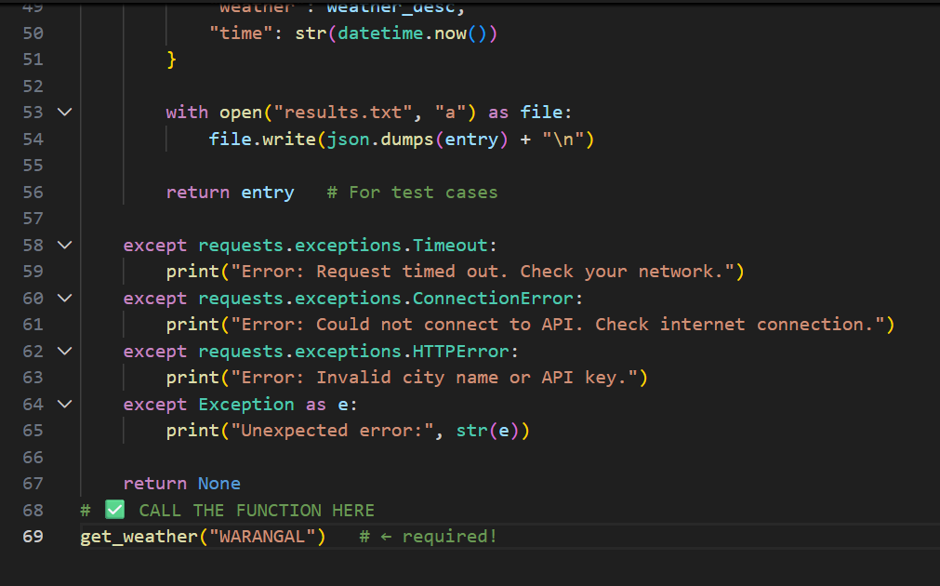
OUTPUT:
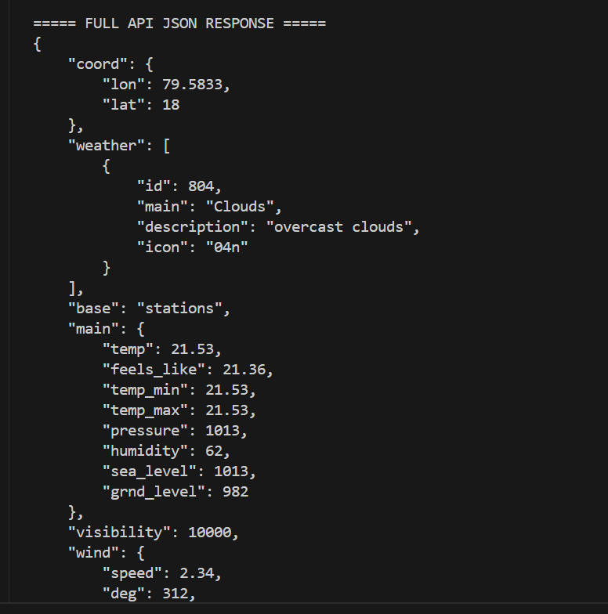
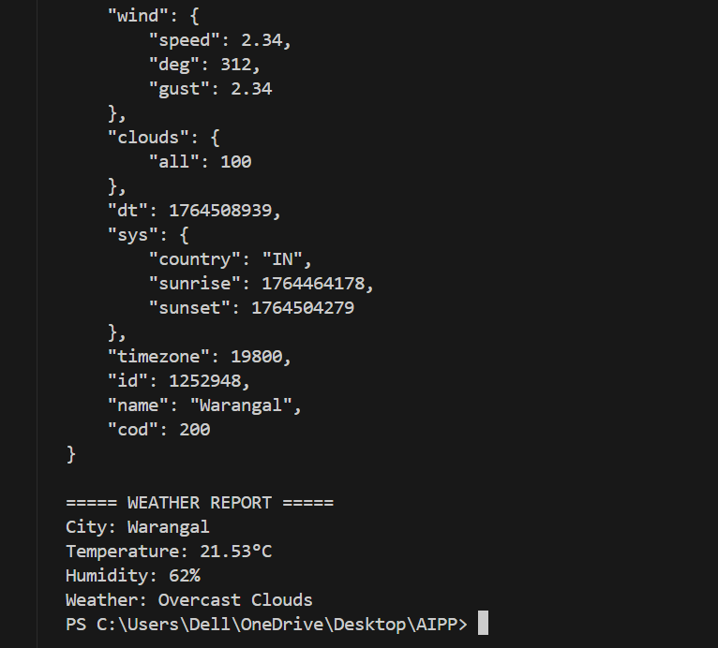
Task 2:
Prompt: write a python function that display weather details of a
city using weather api with error handling. Display weather details
as JSON output.
CODE: 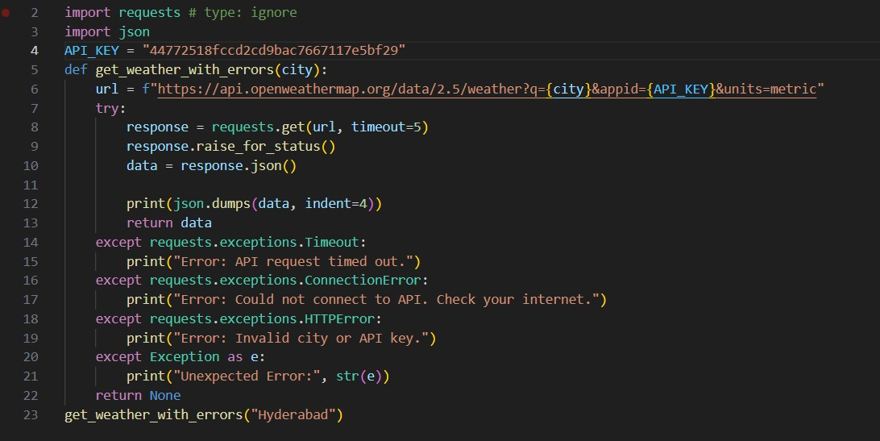

OUTPUT:
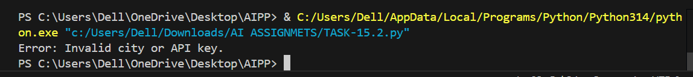
Task 3:
Extract and Display Specific Data
• Instructions:
1. From the API response (e.g., weather API), extract
specific fields (temperature, humidity, description).
2. Display them in a user-friendly format (not raw JSON)
CODE: 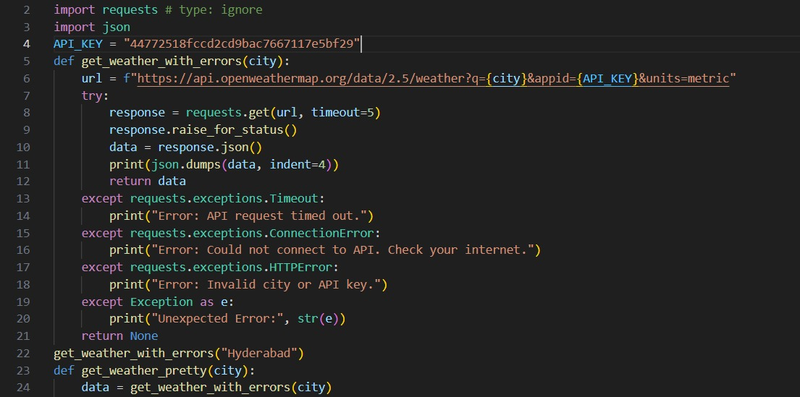
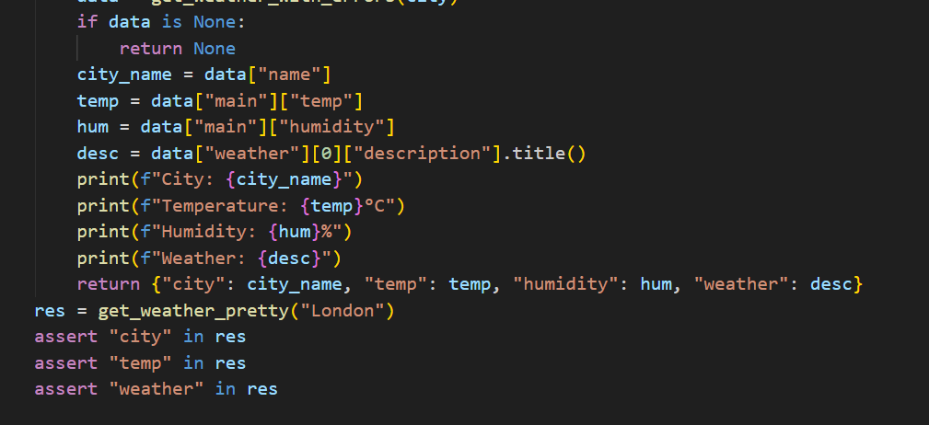
OUTPUT:
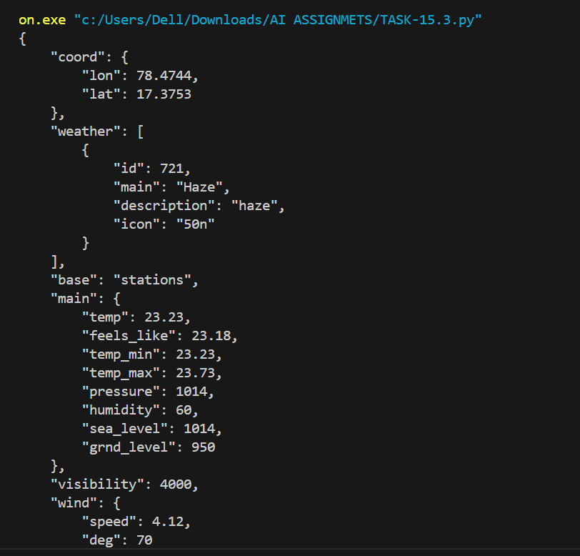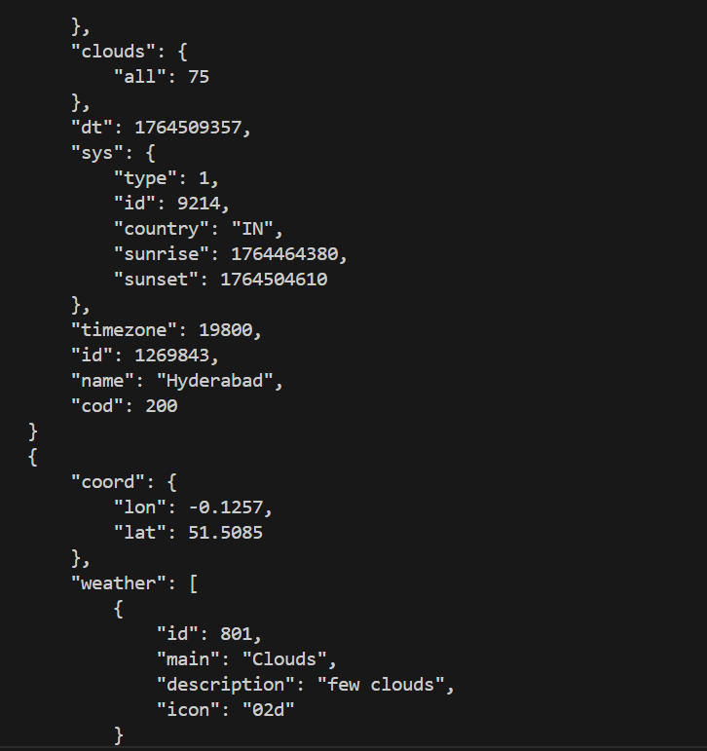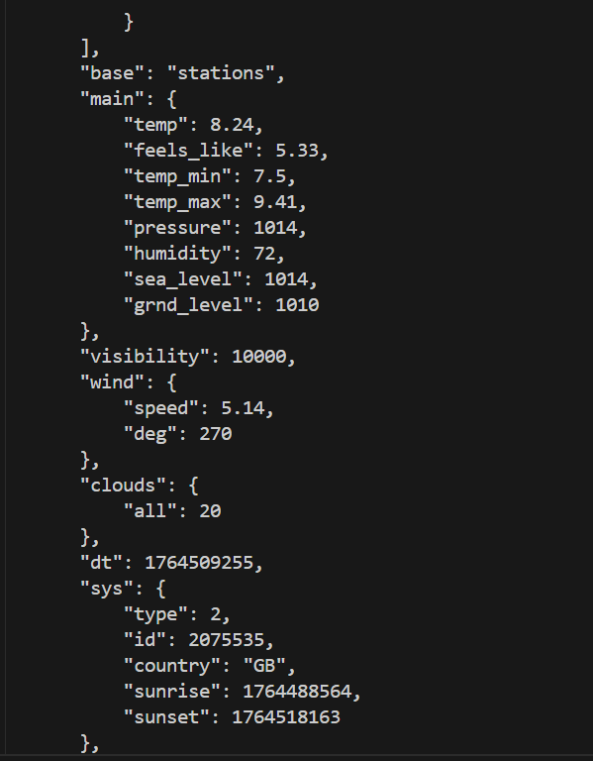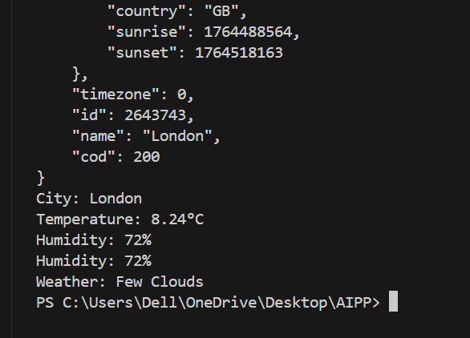

Task 4:
Build a Function with a Parameter. Write a python function that displays weather details of a city using weather api with error handling. Display weather details in user friendly forma
CODE:

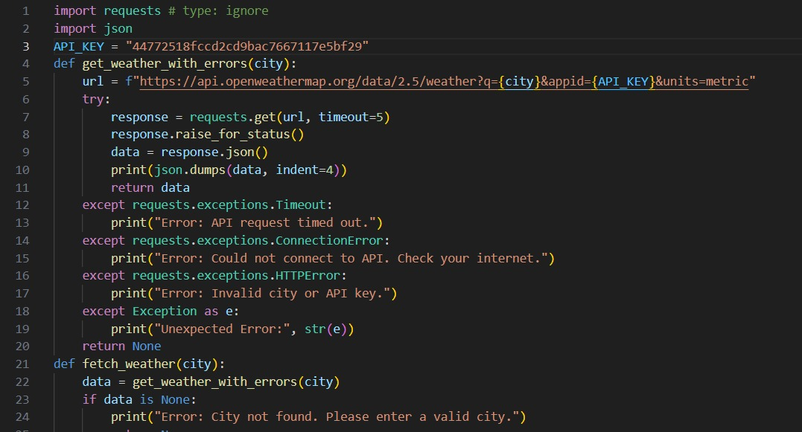
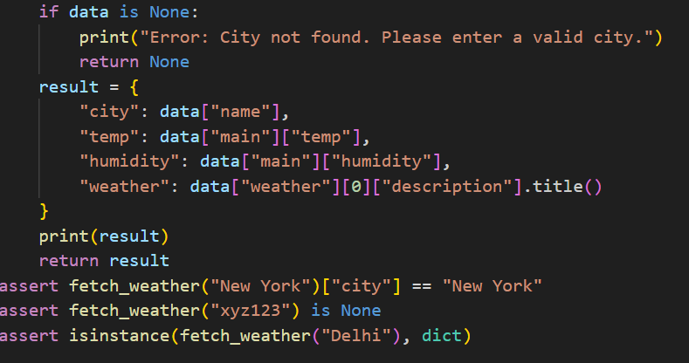
OUTPUT:
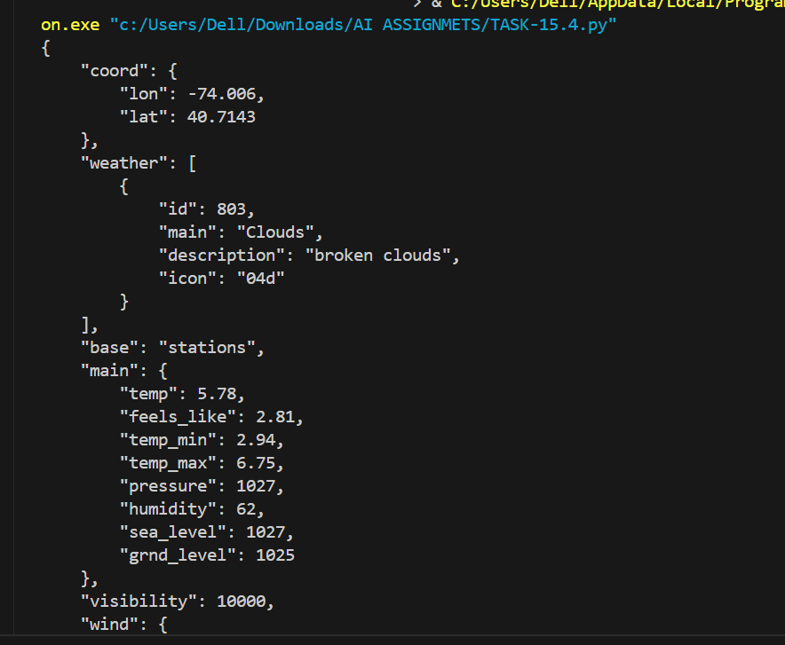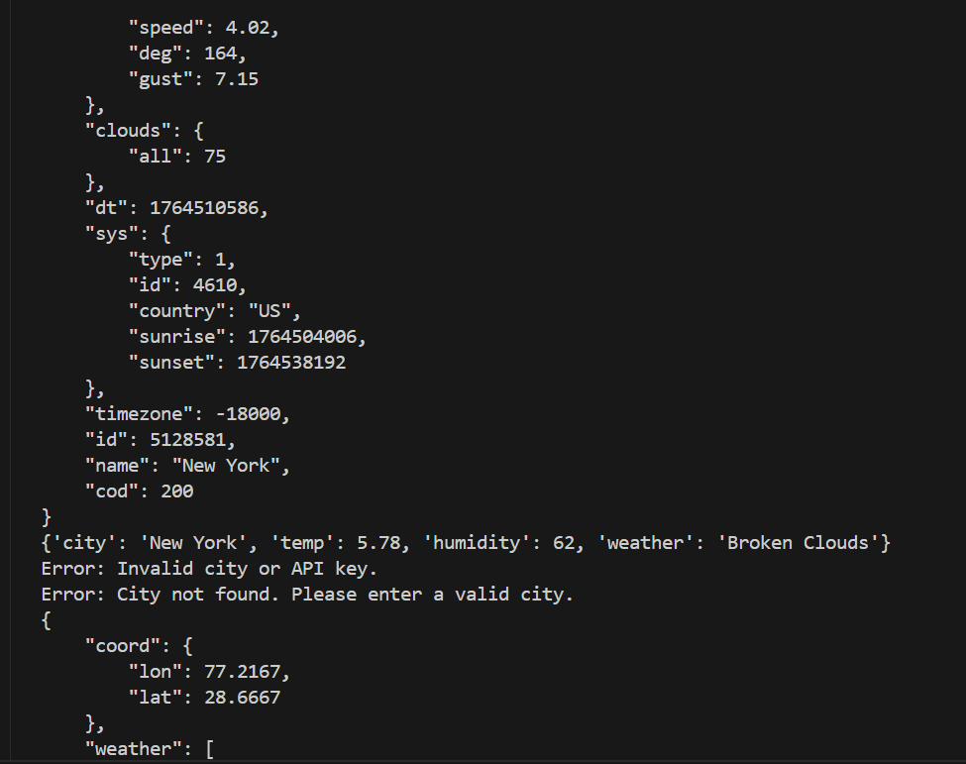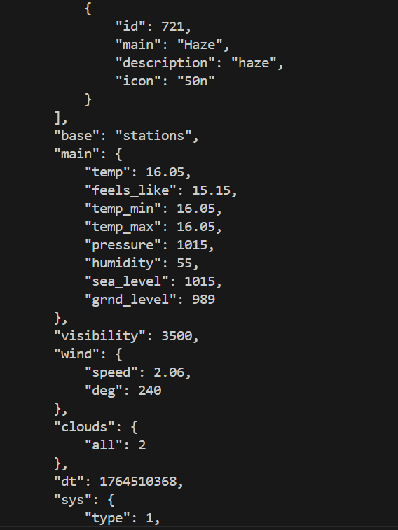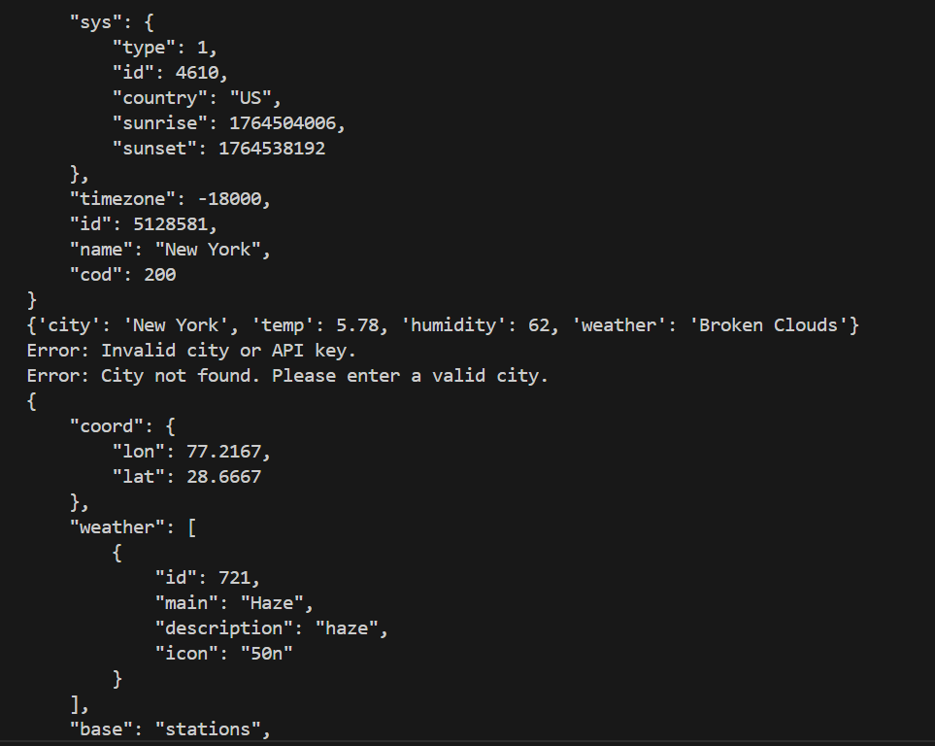
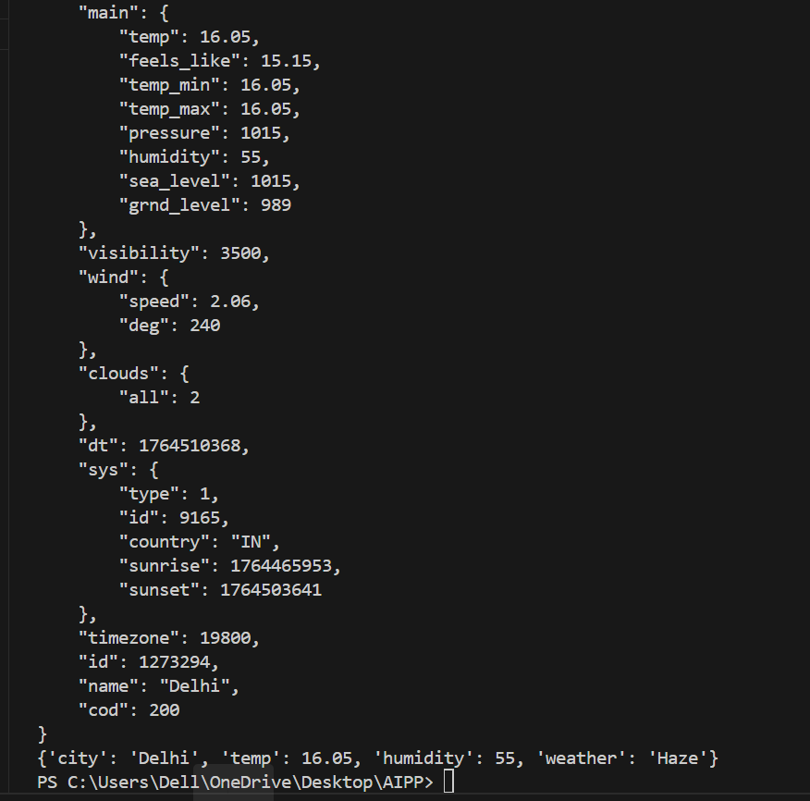
Task 5:
Prompt: write a python function that display weather details of a
city using weather api with error handling. Display weather details
as JSON output. Store the weather details in current directory as
text file, every run output will append.
CODE: 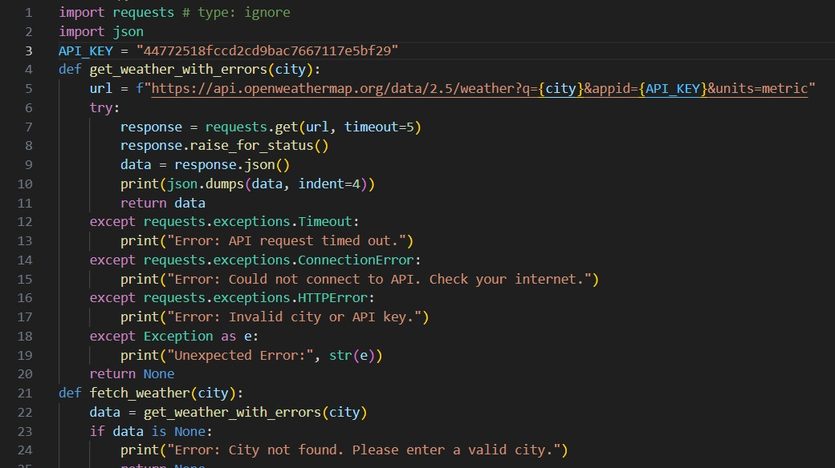
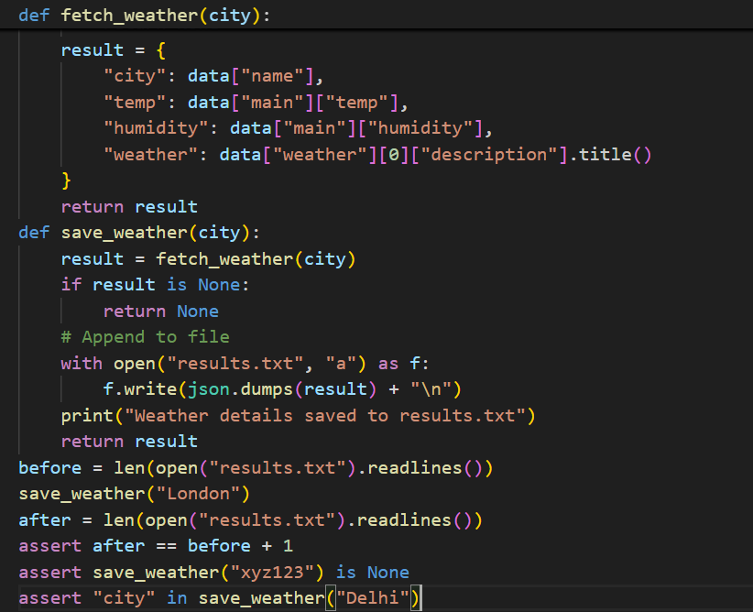
OUTPUT:
 

